# Cambridge Datasets Application

# 

# *Documentation*

Version 4.0  
haselwimmer@gmail.com

5th August 2019

Contents

1. Overview 3

2. Using Application - Overview 4

2.1. External user 4

2.2. Post-Submission 9

3. Setting Up Application 14

3.1. Installing Software 14

3.2. Configuring Software 14

3.3. Setting Up Software for First Use 15

3.4. CSV Import File 25

4. Technical Overview 26

4.1. Drupal Content Types 26

4.2. Drupal Views 28

4.3. PHP Code 31

4.4 Drupal Tutorial 31

## 1. Overview

The **Cambridge Datasets Application** allows external users to submit a formal request to access one or more Cambridge University datasets. The Datasets Application forwards the request to internal reviewers who then submit their comments via the application. A final reviewer approves or rejects the user’s request within the application, based on the comments of previous reviewers.

If a request is approved, access to the relevant dataset(s) is configured manually and the external user is notified accordingly, for example by sending an email with login details to the datasets. While there is significant scope to automate this final stage of the process, no automation has been implemented in this version of the application; any automation code is likely to vary significantly from department to department depending on how datasets are stored.

The **Cambridge Datasets Application** uses Drupal as an application framework as it provides good management of users through pre-existing admin screens, close integration with Cambridge University’s Raven Single Sign On (SSO), and runs on PHP/MySQL which has a large support base in the University. Switching between Cambridge University’s “Project Light” design template and other design templates is also relatively easy through Drupal’s templating system.

The **Cambridge Datasets Application** was created in Drupal 7, rather than Drupal 8, to provide consistency with the University’s existing Drupal 7 “Project Light” templates and Drupal 7 “Cambridge Profile”. The “Cambridge Datasets Application” extends the “Cambridge 2.0 Full Profile” available from:   
<https://github.com/misd-service-development/drupal-cambridge-profile/releases>

The specific components of the Drupal application are as follows:

* **1. Drupal Content Types and Views**: A variety of Drupal *content types* were created within Drupal to manage different types of data, eg. “Dataset” and “Request”. A range of Drupal *views* were used to display the data in specific ways, eg. “Edit requests”.
* **2. Drupal Module**: The Drupal PHP module **cambridge_datasets** provides bespoke functionality not possible through Drupal’s UI interface. The module interacts with Drupal’s object layer to create, edit and delete content in a Drupal-compliant way.
* **3**. **Interaction with other systems**:A “cron job” (ie. scheduled job) runs on the webserver to force Drupal to process its mail queue. It may also be appropriate to integrate the application with external data storage systems such as “Amazon S3” to ensure successful applicants are given access to datasets in an automated way.

## 2. Using Application - Overview

### 2.1. External User

An external user loads a **Cambridge Datasets** website:

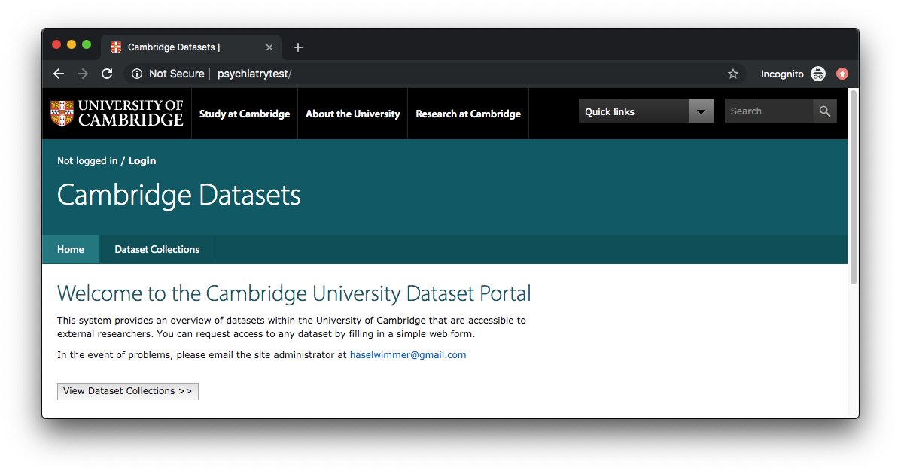  
They click “View Dataset Collections” to view list of dataset collections:

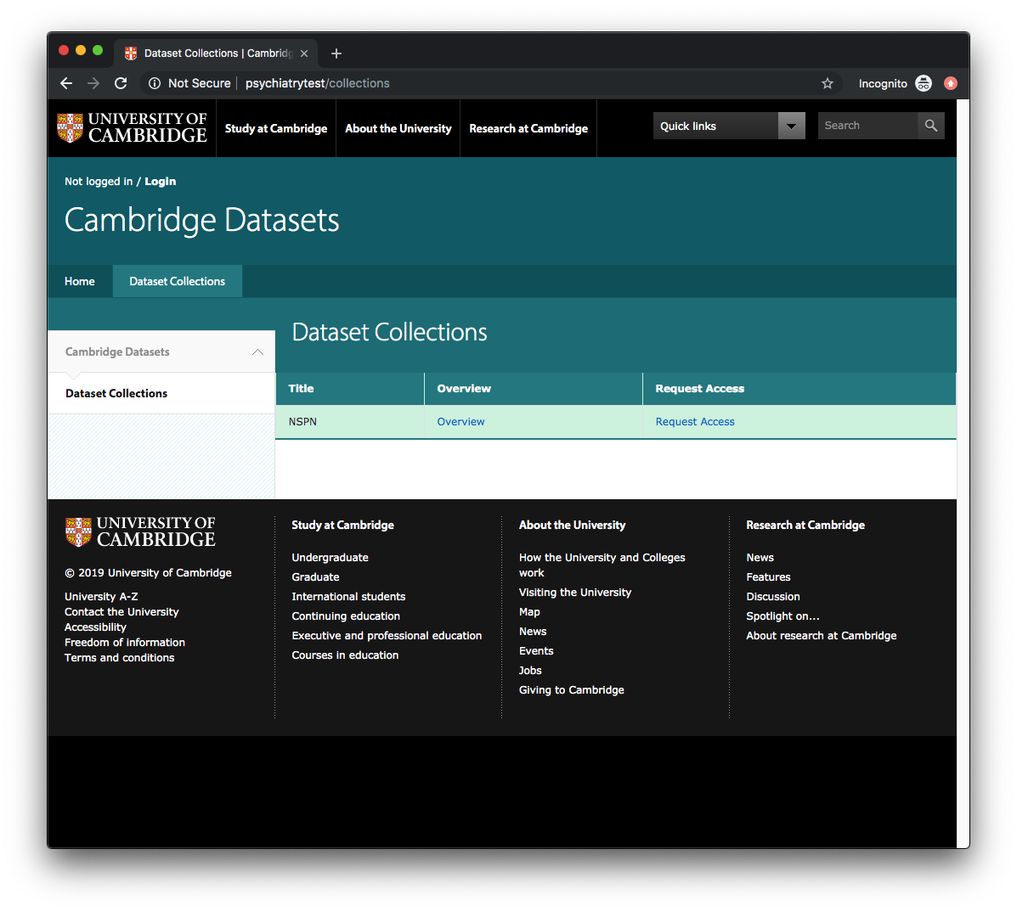

They then click “Overview” to view an overview of a specific “Dataset Collection” including the list of datasets within that collection:

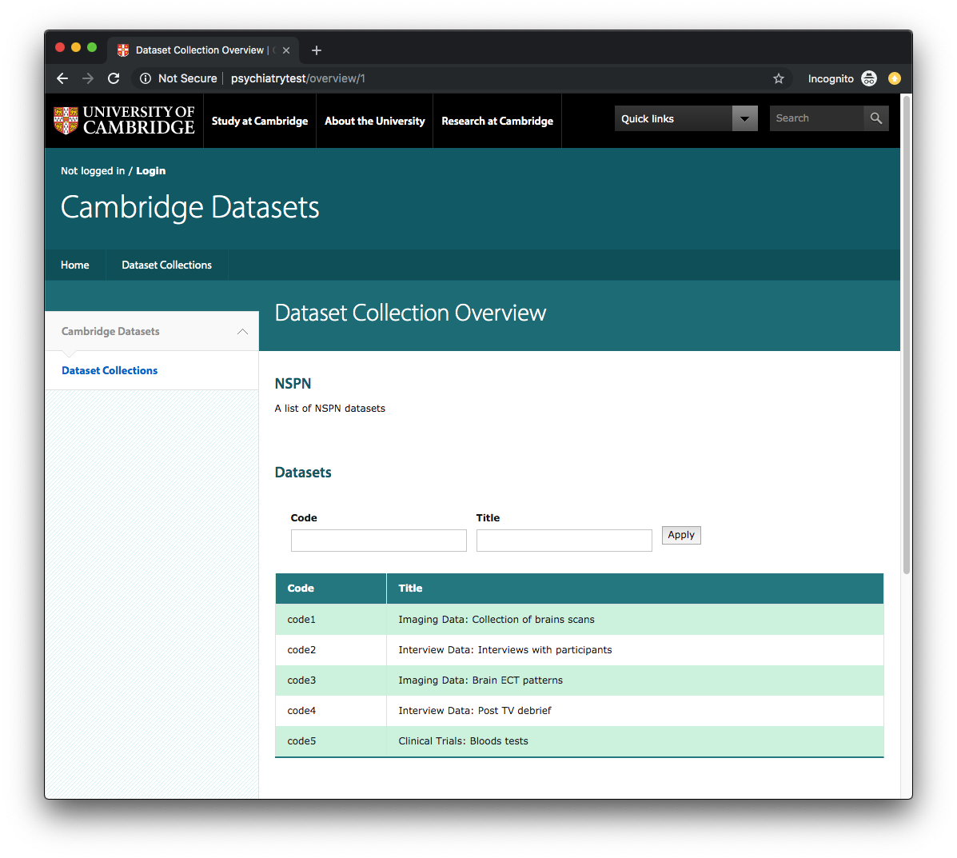

The user can enter text in the “Code” or “Title” input fields and click “Apply” to filter the visible datasets:

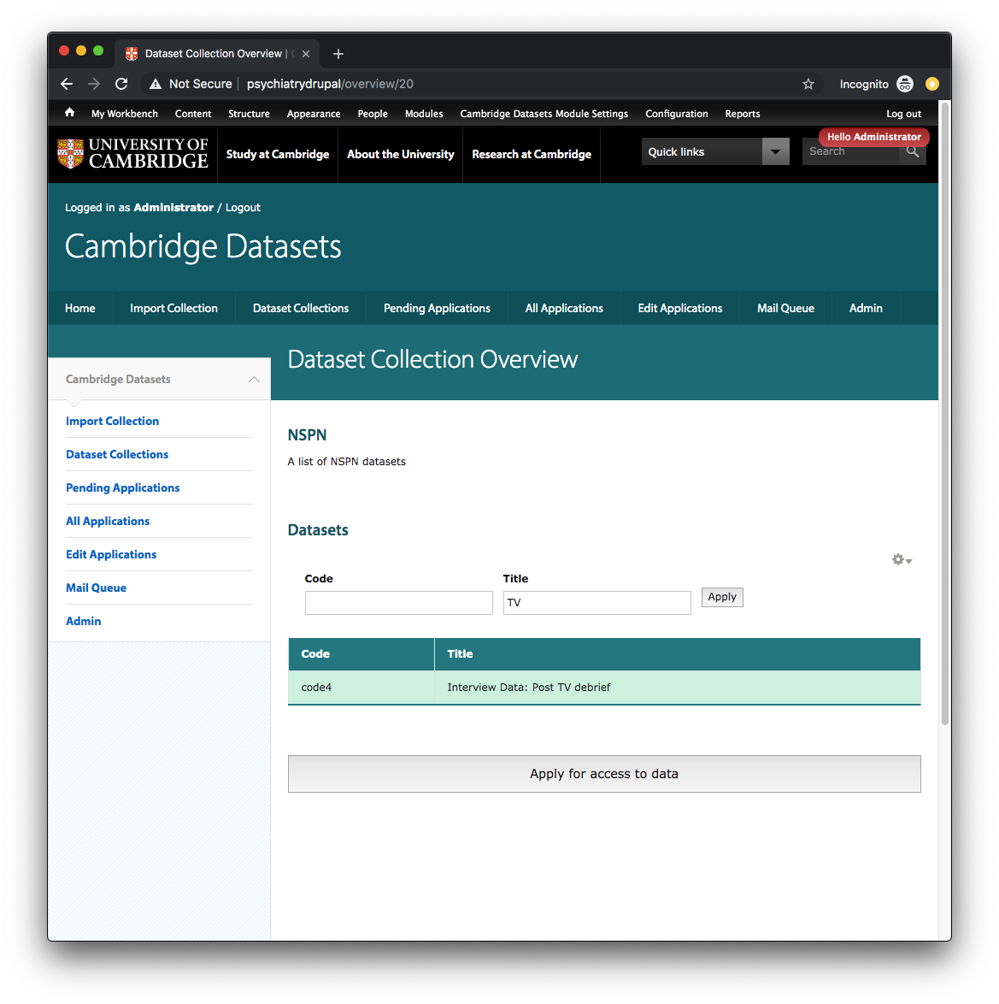

The user can request access to one or more datasets within the dataset collection by clicking “Request access to datasets”. They will be presented with an initial terms and conditions page:

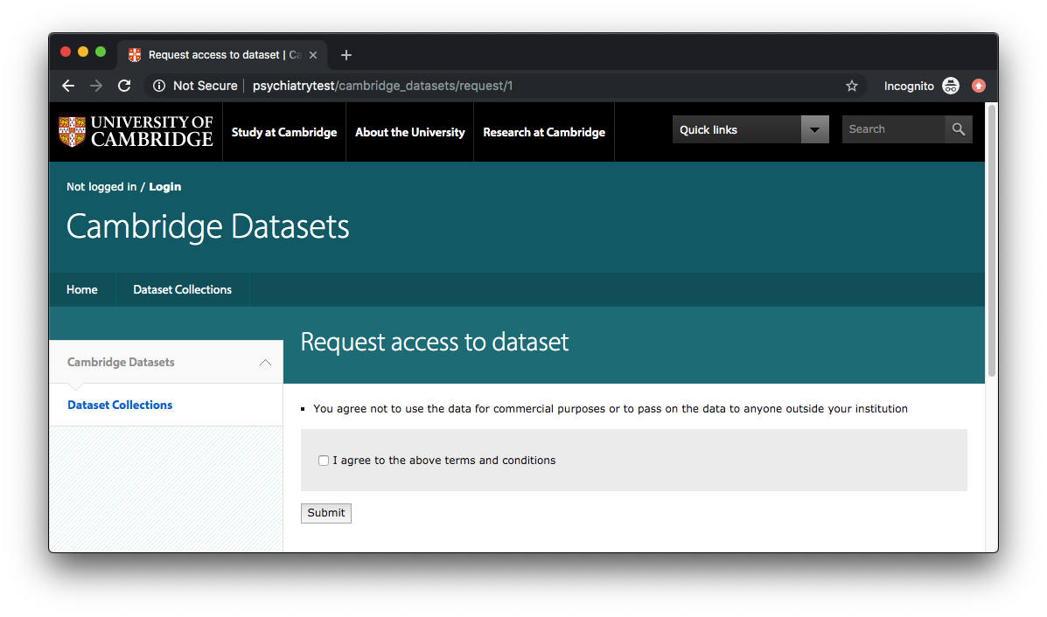

Once the user has agreed to the terms and conditions, they are transferred to a data request form where they can fill in their details, describe their research proposal and select their desired datasets:

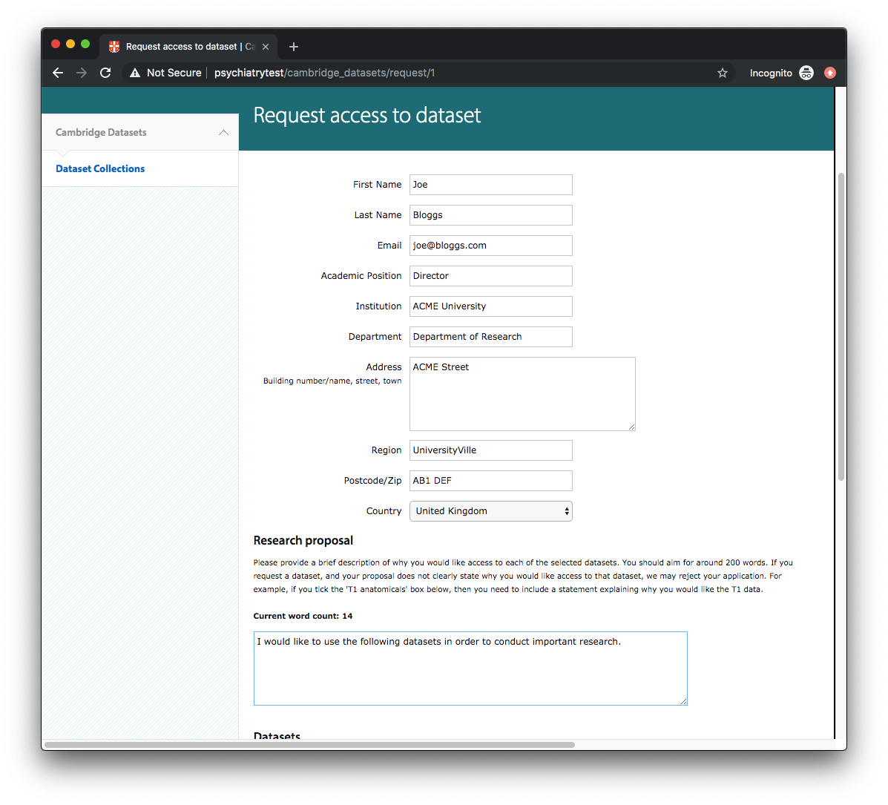

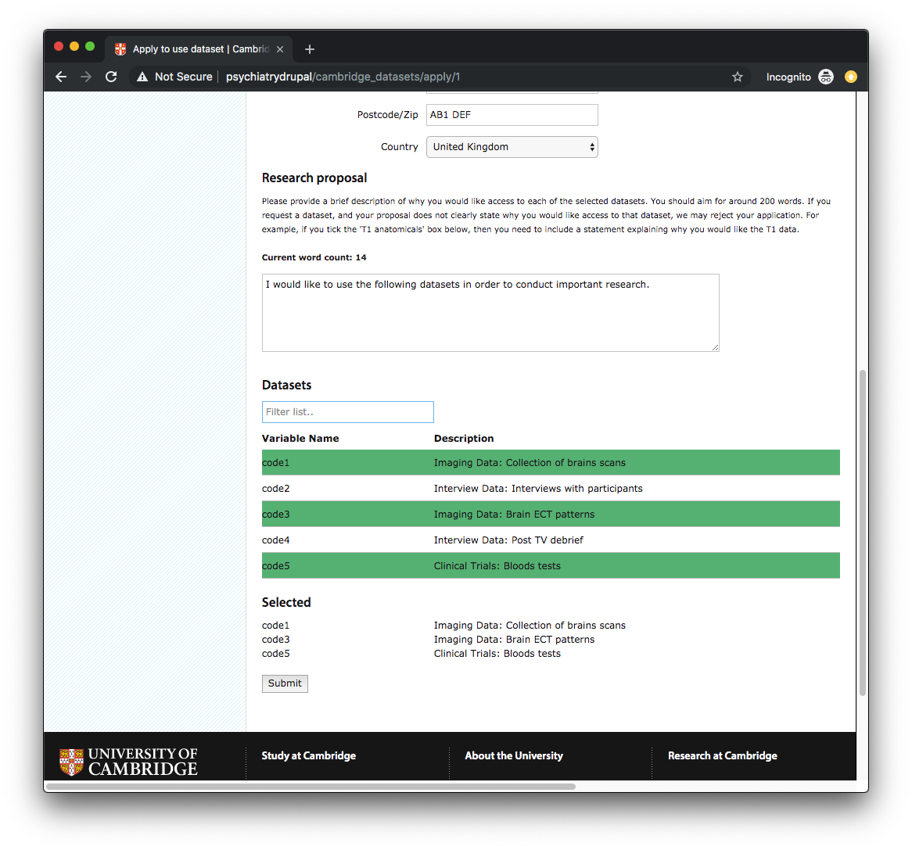

The system requires the user to complete every field before the form can be submitted. Once the form has been submitted, the user will be given a simple alert confirmation:

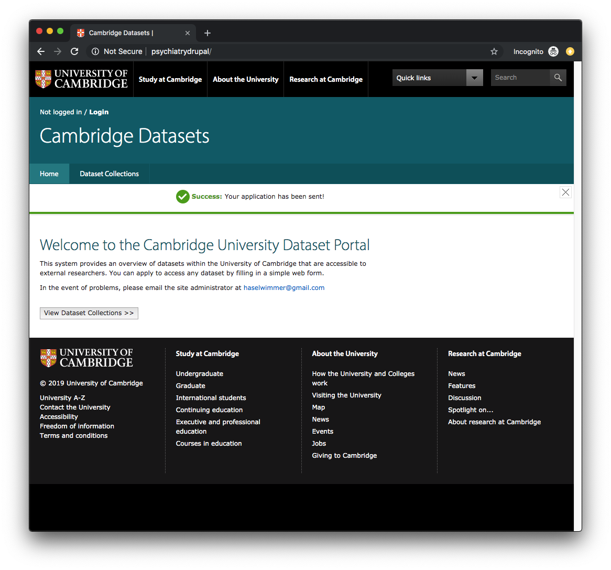

### 2.2. Post-Submission

Following a successful request, each reviewer/final-reviewer attached to a dataset collection will receive an email informing them a request has been received that requires review:

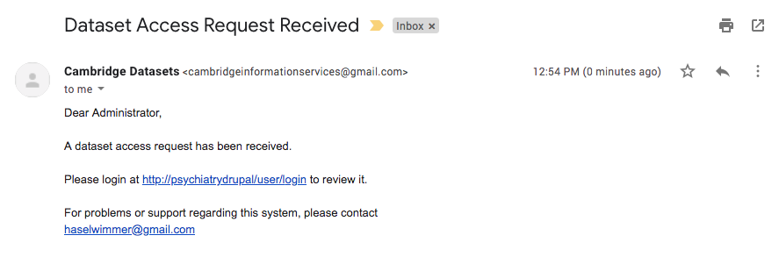When the reviewer/final-reviewer log in to the system, they will be presented with an admin screen:

#### Standard Reviewer

A standard reviewer will see the following screen:

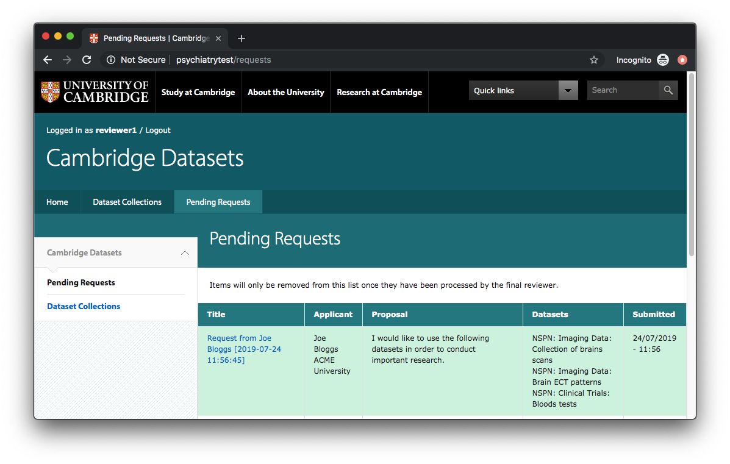

They can click on the pending request in the list to review the request and add an Accept/Reject/Query comment:

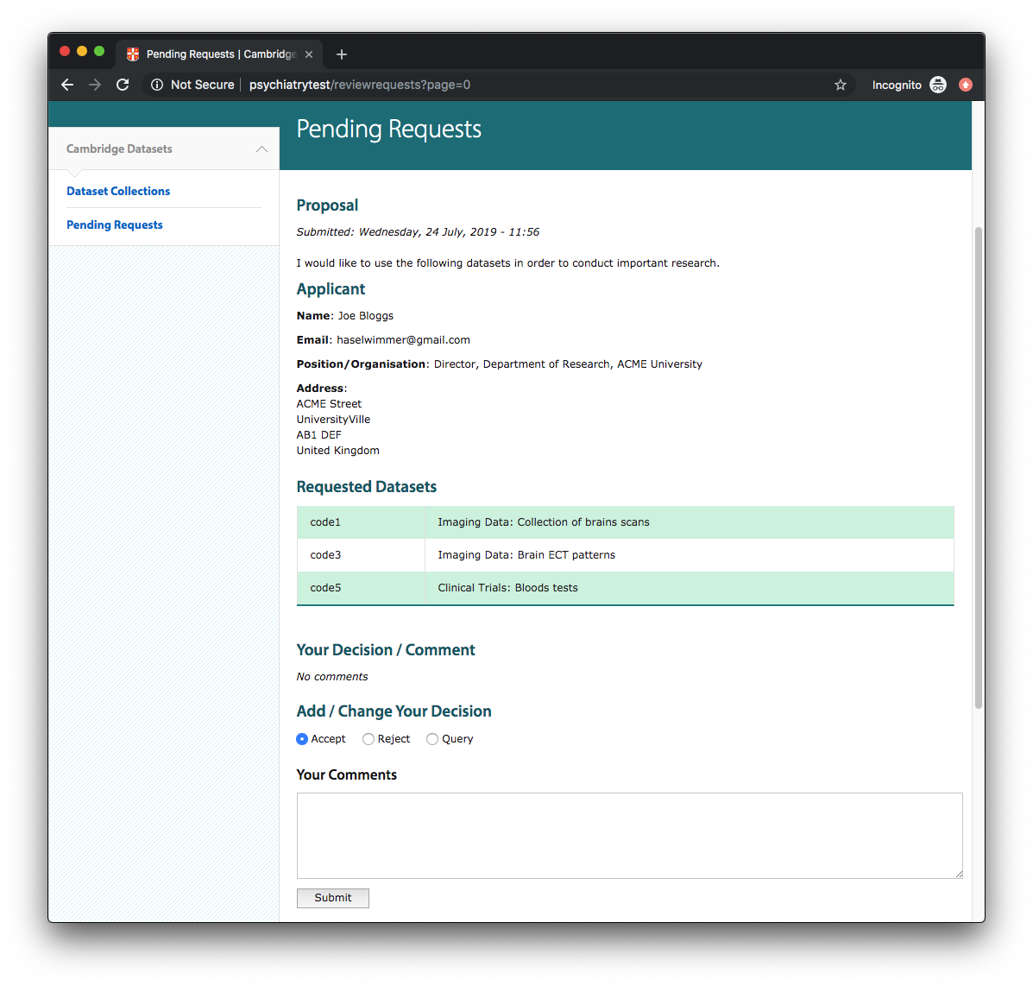

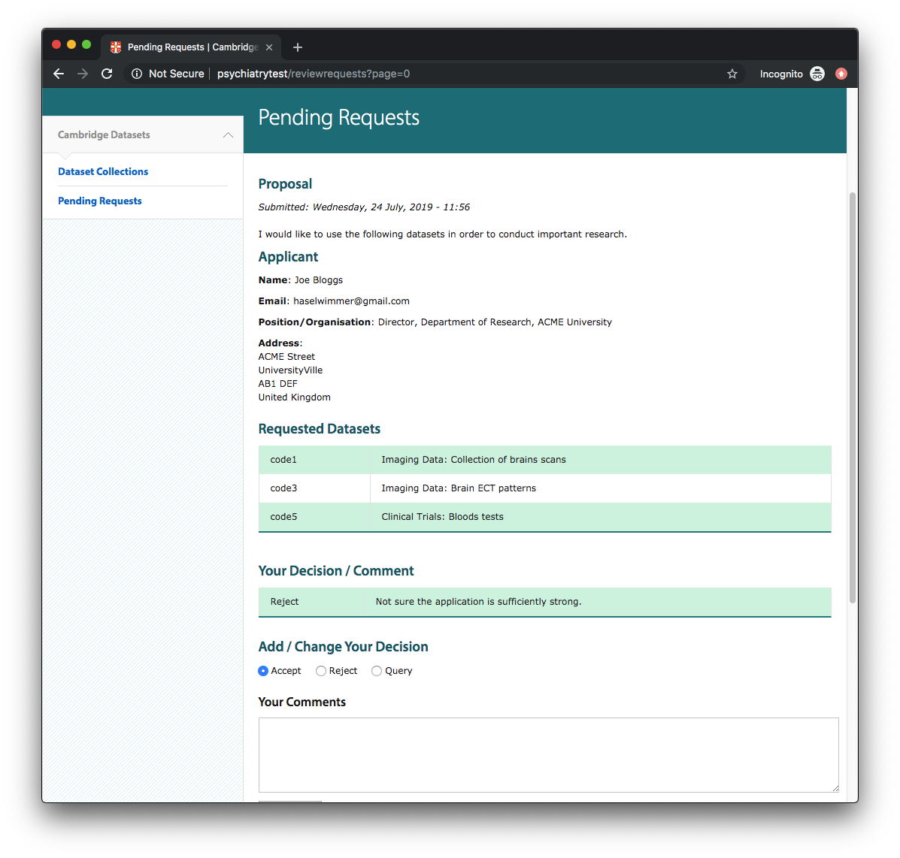

The user can overwrite their previous decision/comment by completing the “Your decision” section again and resubmitting the form:

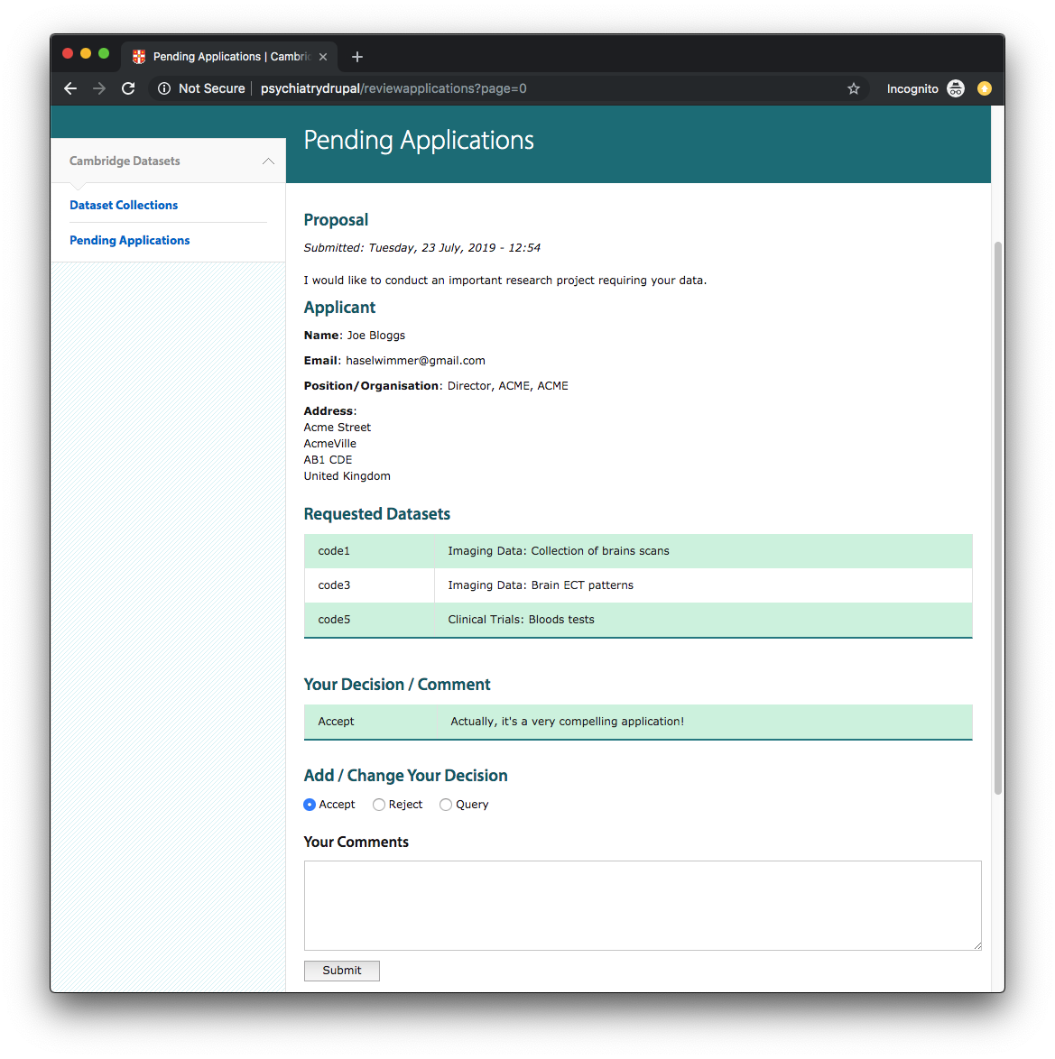

Once a reviewer has added decisions/comments to all pending requests, they click “Logout” to logout.

#### Final Reviewer

When a “final reviewer” logs in, they see a similar screen to a conventional “reviewer” but with the addition of an “All Requests” link:

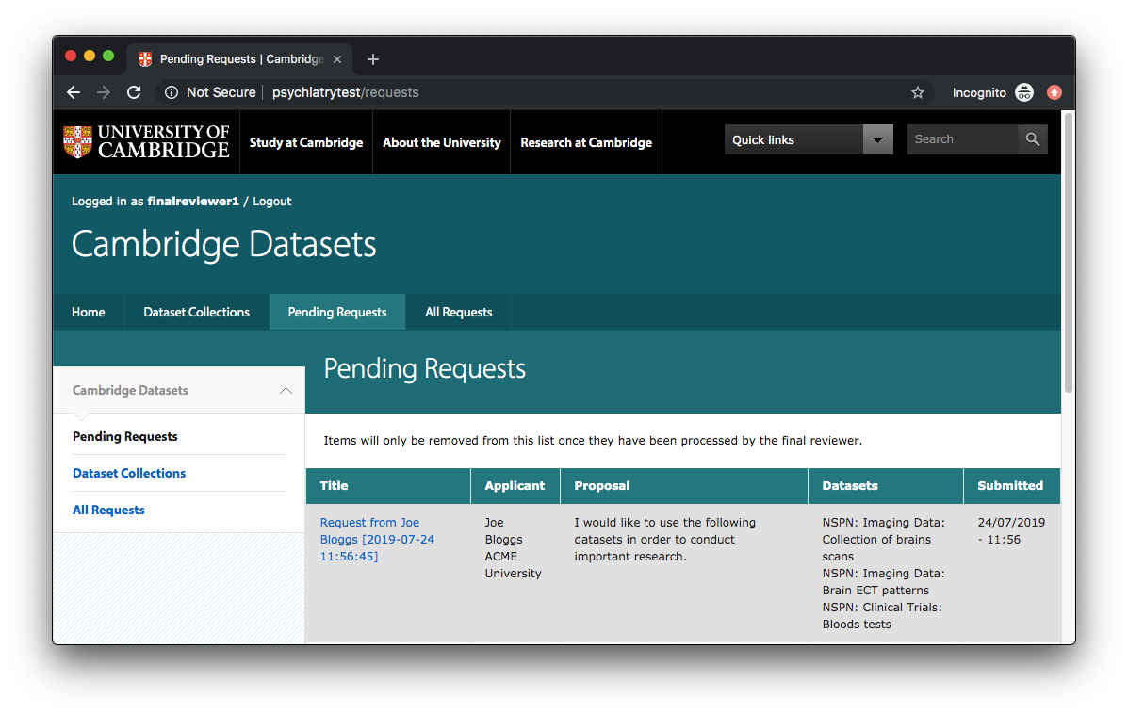A final reviewer can add comments/decisions like a conventional reviewer, but they can also “Reject”, “Approve” or “Processed” the request using one of the buttons on the top of the page:

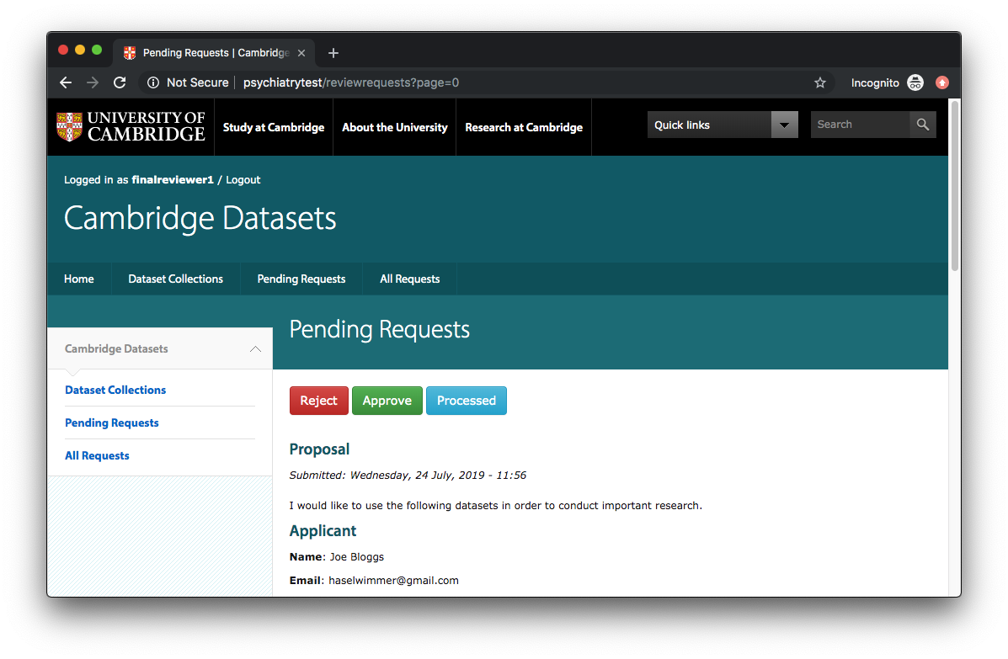

Clicking Reject/Approve/Processed will remove the request from the list of pending requests for ALL reviewers:

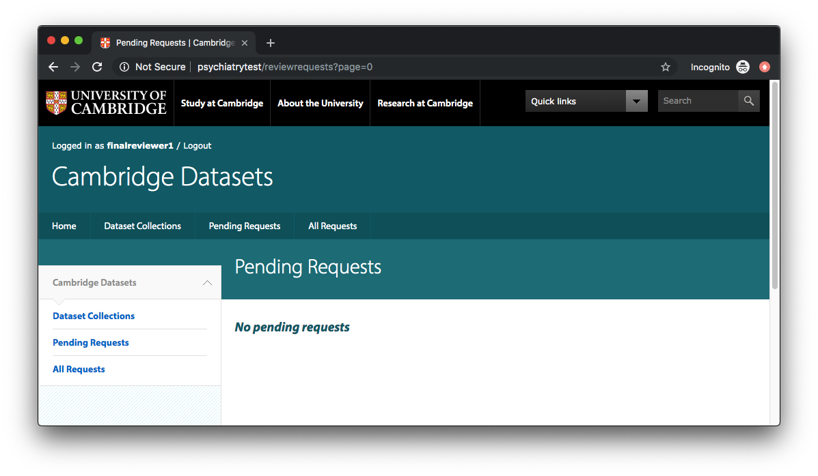

[*Not yet implemented*: Once a request has been “Processed”, an email will be sent to the applicant with details of how they can access the datasets they requested.]

If a request is rejected/approved/processed by mistake, a final reviewer can click “All requests”, select the appropriate request and “Revert” its status to “Submitted”:

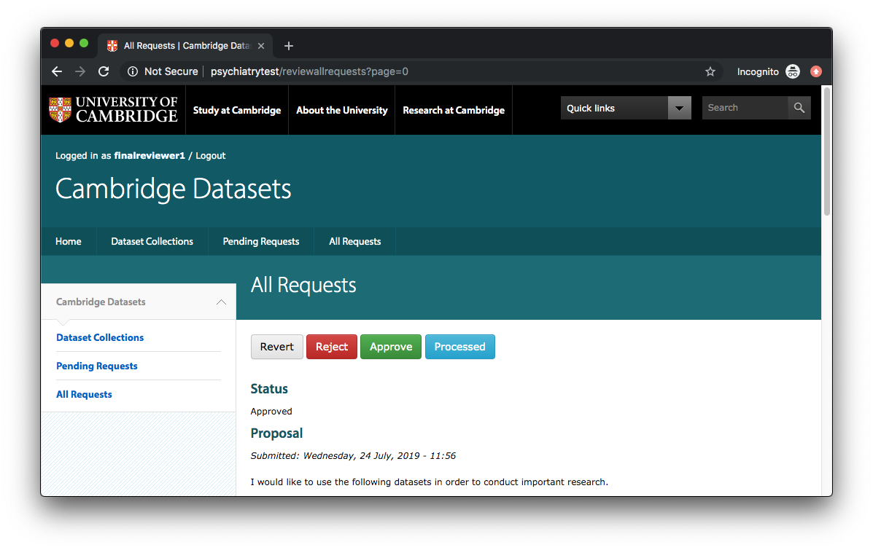

This will cause the reverted request to reappear in the list of all “Pending Requests”.

## 3. Setting Up Application

### 3.1. Installing Software

To install the software on your webserver, follow the instructions at:

[**https://github.com/Cambridge-IDE/cambridge_datasets_application**](https://github.com/Cambridge-IDE/cambridge_datasets_application.git)

Once you have successfully installed your software, you should see the following screen:

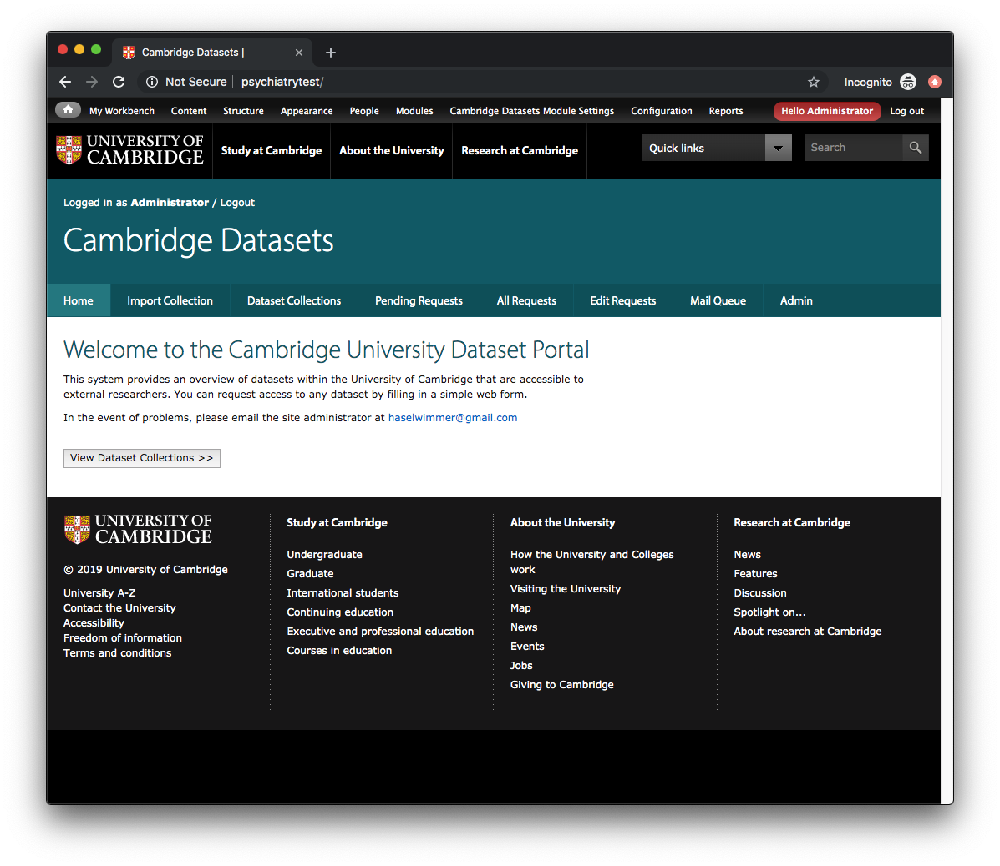

This is the view presented to all users with “Administrator” permissions.

### 3.2. Configuring Software

Set up your SMTP mail server settings, your requests backup folder and your server “cron job” using the instructions at:

[**https://github.com/Cambridge-IDE/cambridge_datasets_application**](https://github.com/Cambridge-IDE/cambridge_datasets_application.git)

### 3.3. Setting Up Software for First Use

#### Create Reviewers – Non-Raven

Before you import any dataset collections, you will need to create at least one “reviewer” and one “final reviewer” (they can be the same person).

To add users to the system, click the “Admin” tab while logged in as “Administrator”:

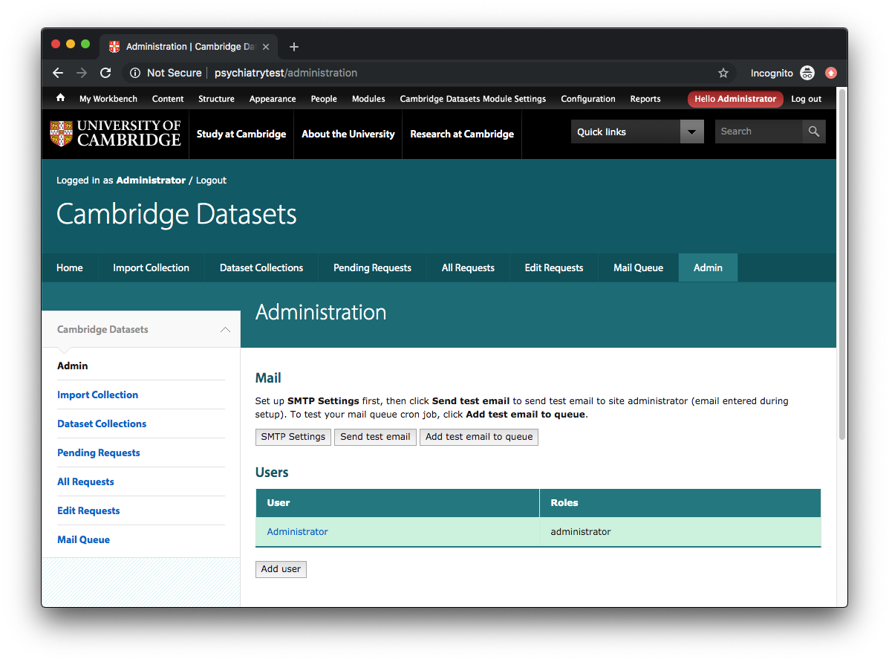

Click on “Add user”: 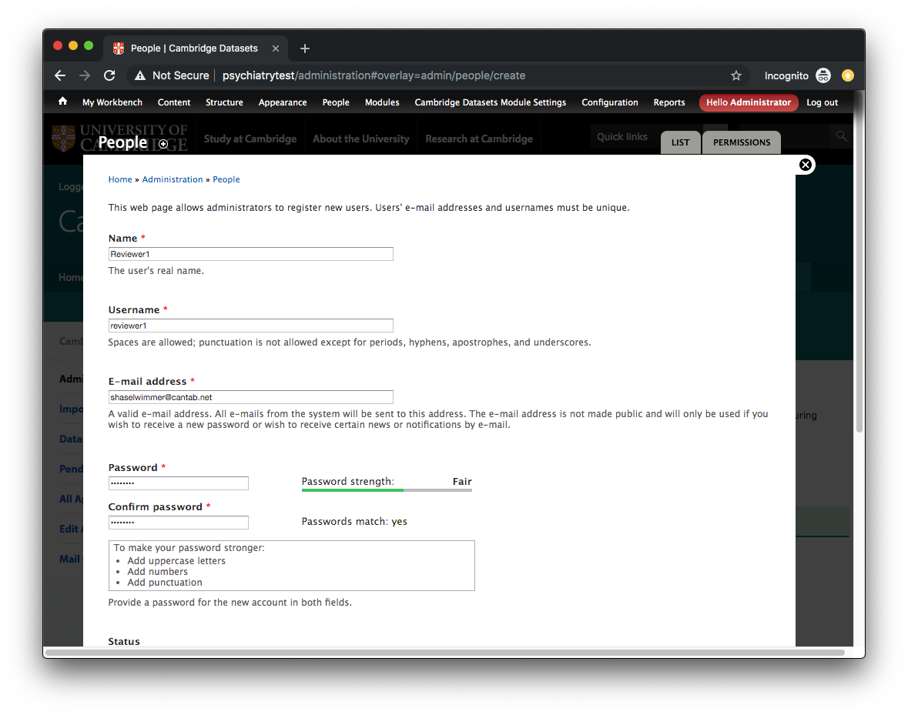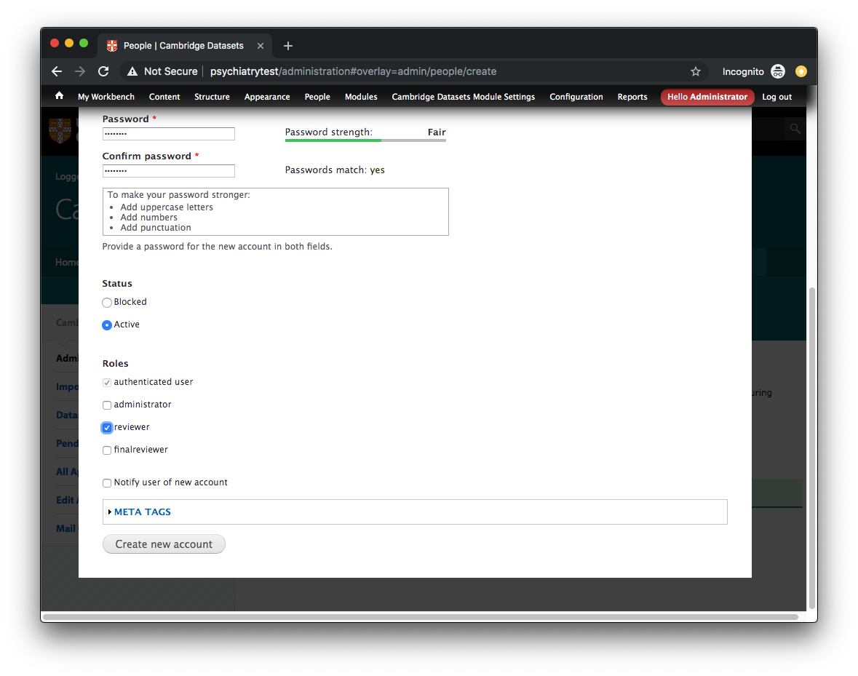

Click the “reviewer” checkbox for each standard reviewer and the “finalreviewer” checkbox for each final reviewer.

You should end up with a list of reviewers/final-reviewers:

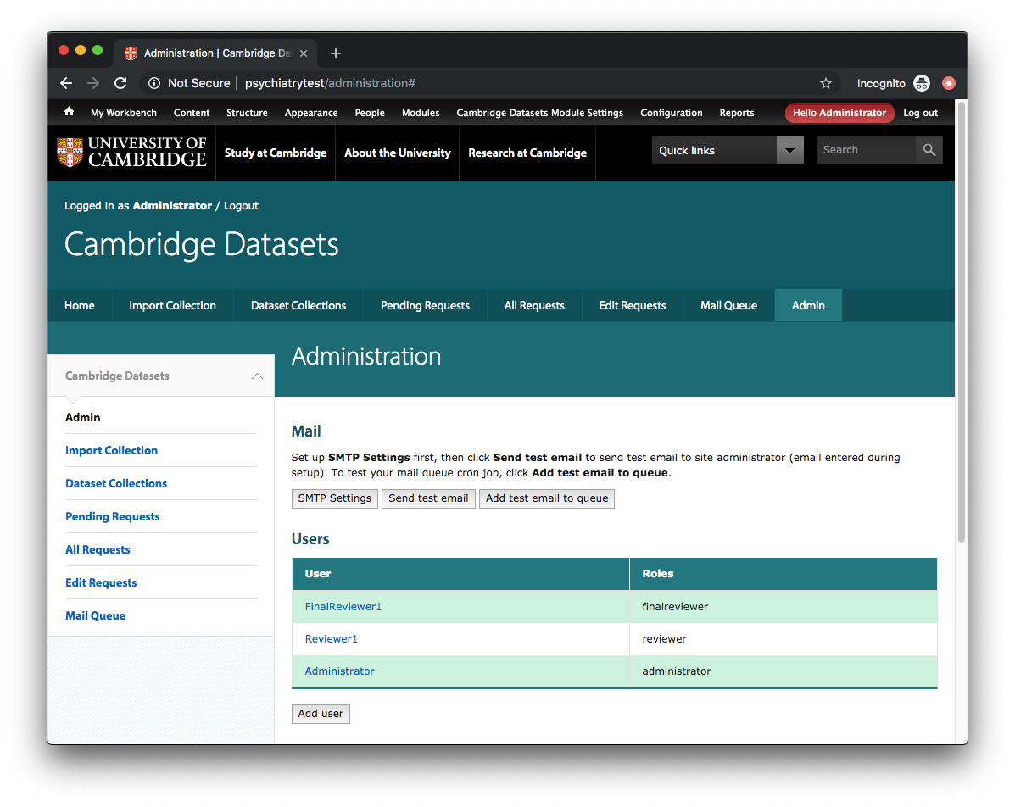

#### Creating Reviewers – Raven

Ask each potential reviewer to load the Datasets Application and attempt a Raven login by clicking on “log in with Raven” (next to “Have a Raven account?”):

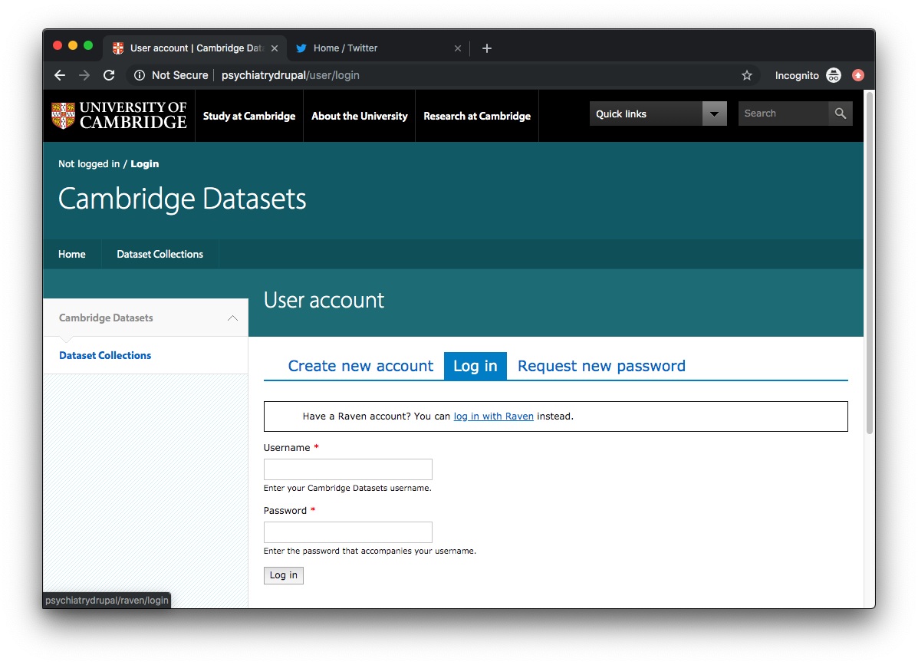

When the user clicks on “log in with Raven”, they will be transferred to the Raven login page.

Once the user successfully authenticates with Raven, they will be returned to the Datasets Application with the following screen:

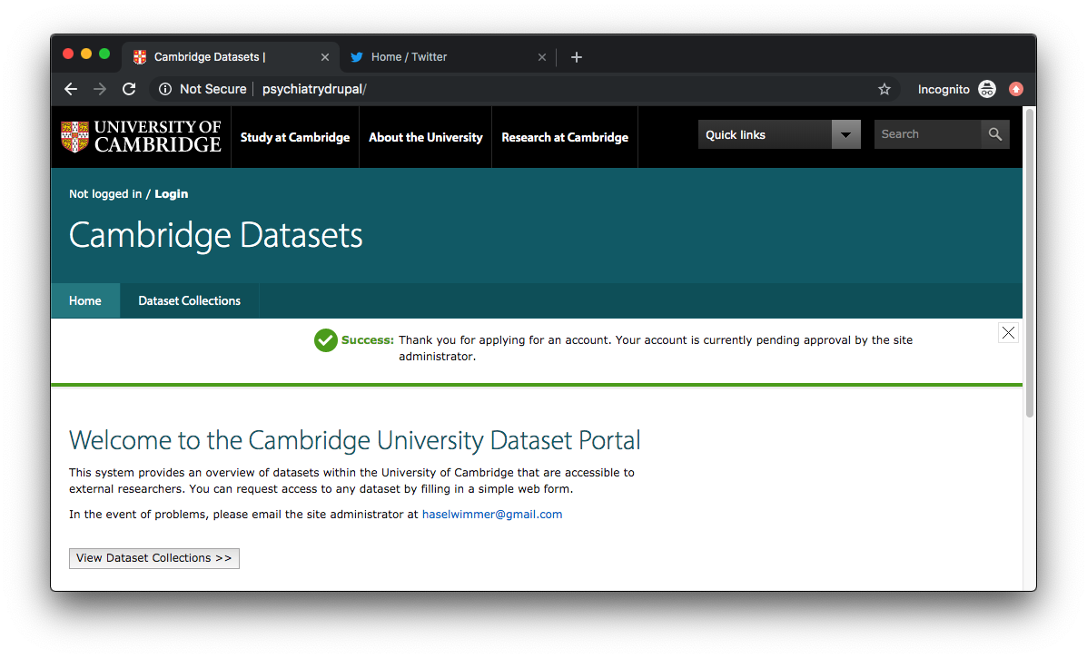

Their account will initially be **blocked** – this is standard procedure for all new Raven logins.

To activate a blocked account, login as “Administrator” and click “People” on the top menu bar:

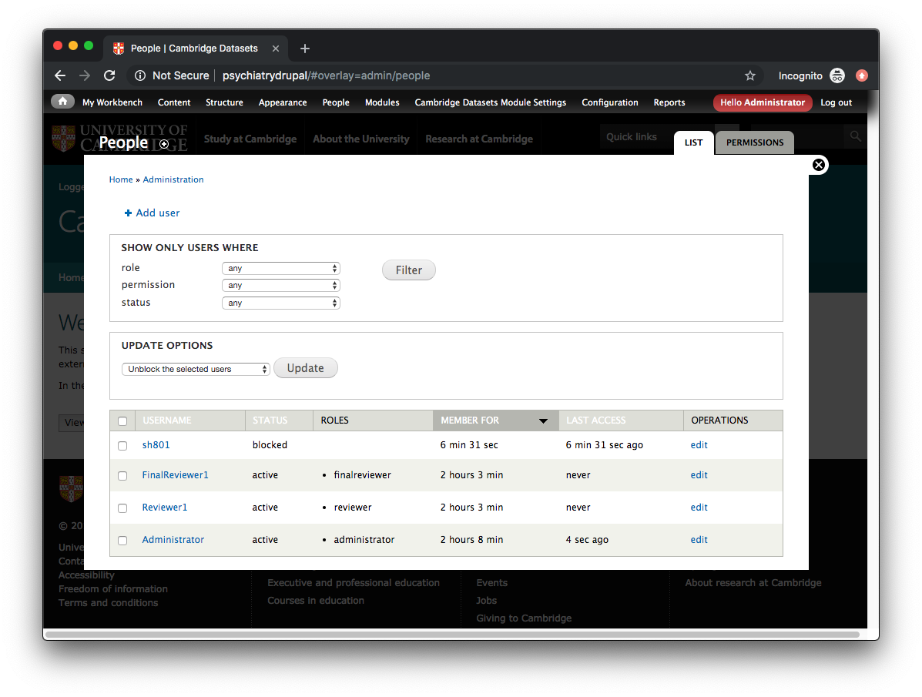

Click “edit” to edit a specific user, then enter a name in the “Name” field, click “Active”, select either “reviewer” or “finalreviewer” as the role, and click “Save”:

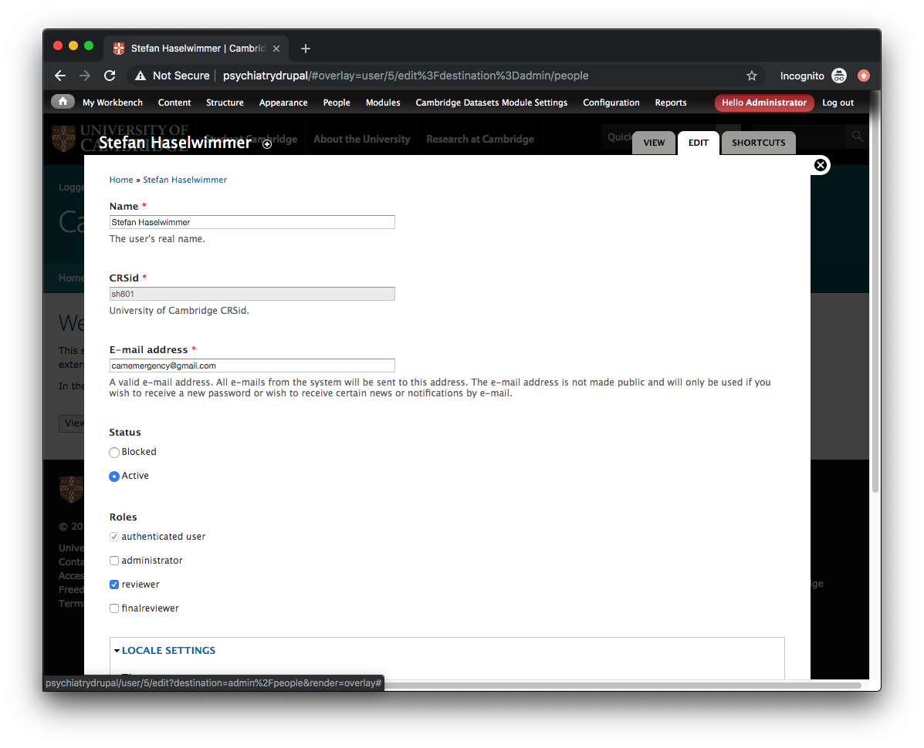

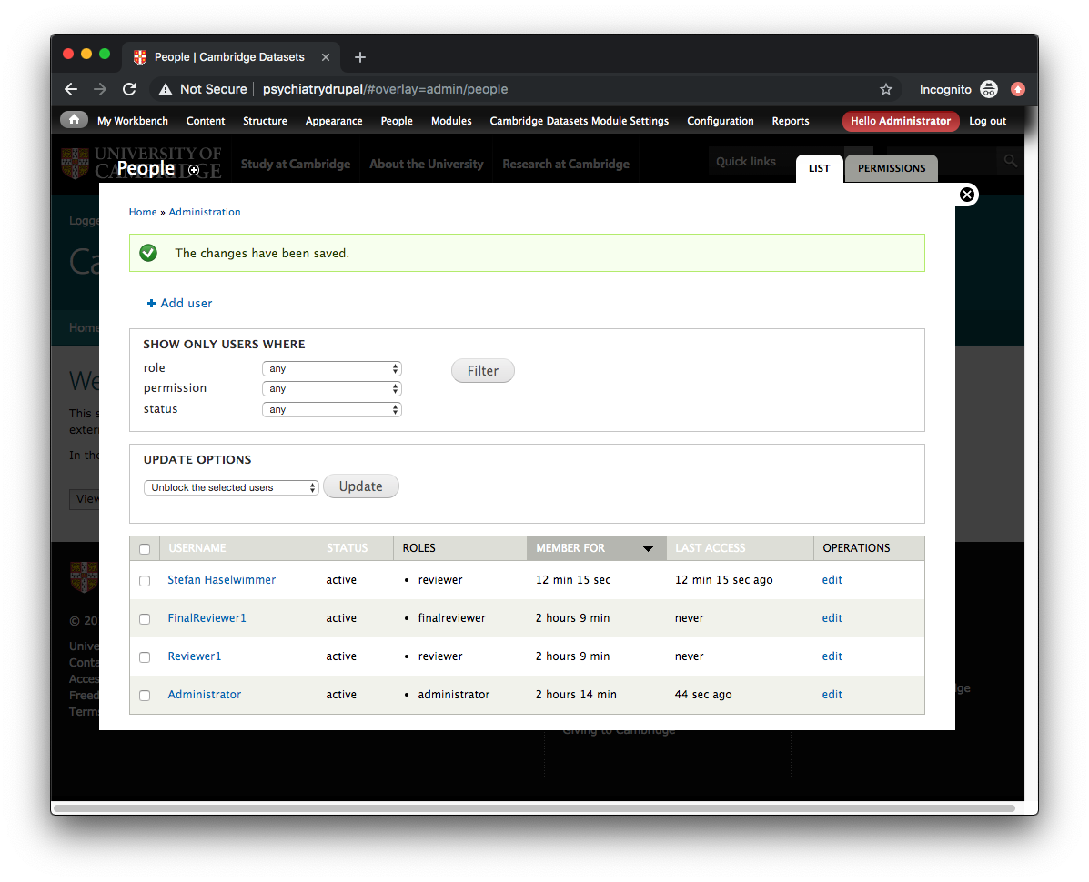

When the Raven user next attempts to login to the Datasets Application, they will be successful:

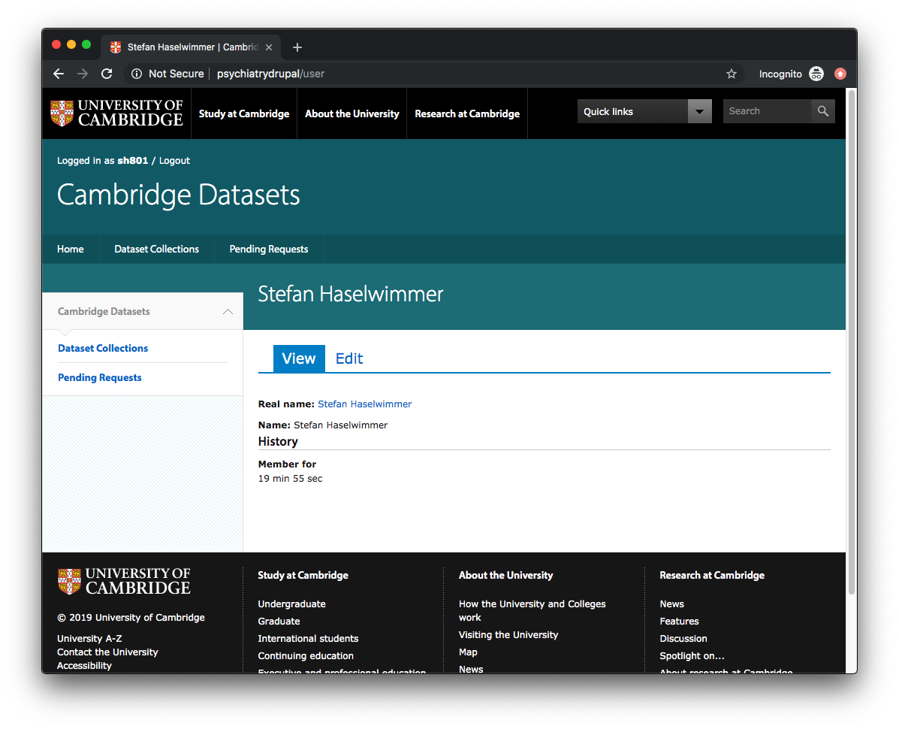

Once you have a reviewer and a final reviewer, you can import your first dataset collection:

#### Importing a Dataset Collection

While still logged in as “Administrator”, click on “Import Collection” to display the import page:

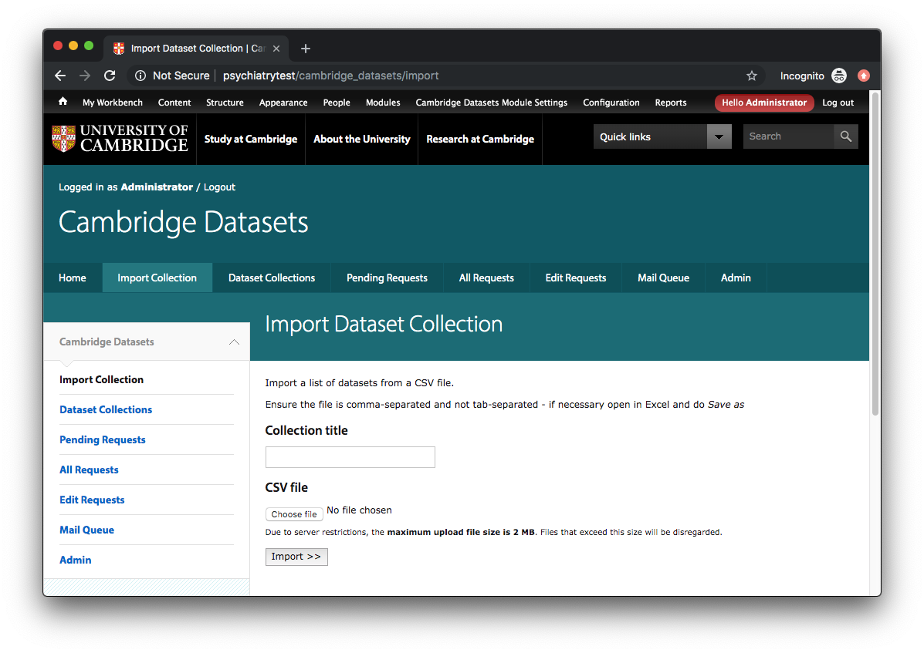

Enter the name of the dataset collection in the **Collection title** field then select a “comma-separated” (CSV) file by clicking on **Choose file**;for information about the precise specification of the CSV file, see “CSV Import File” section below. Click “Import >>” to start the import procedure:

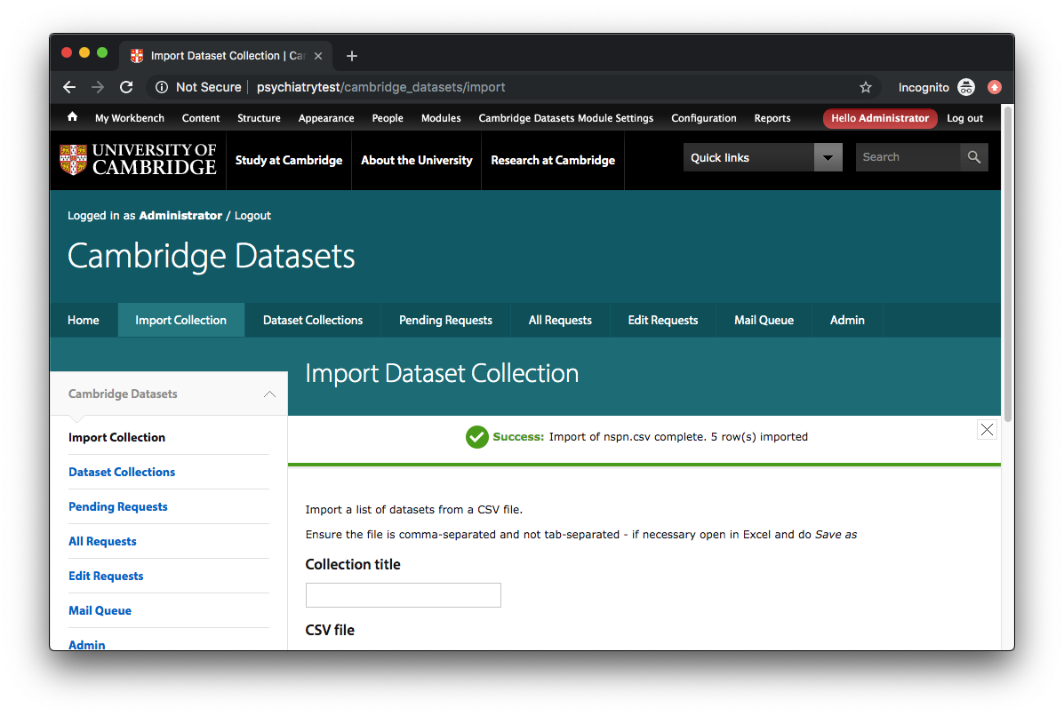

To view the imported dataset collection, click on the “Dataset Collections” link:

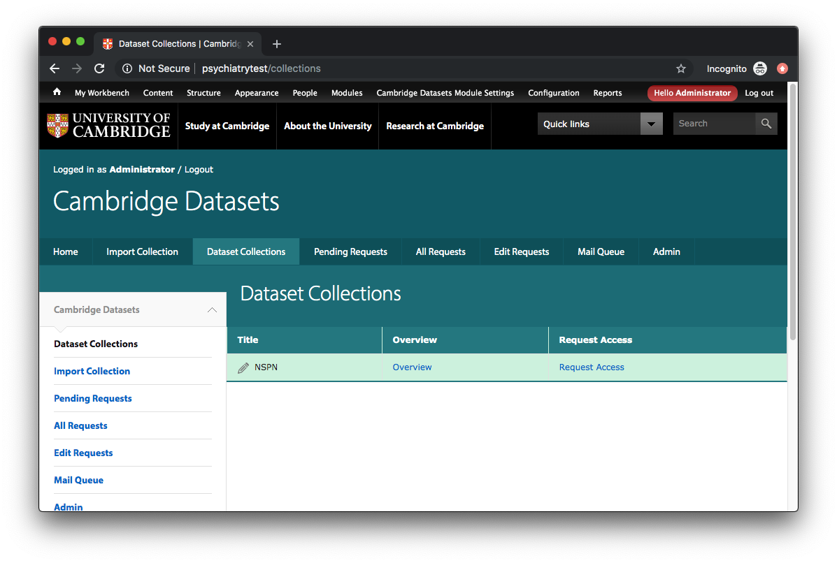

Once a dataset collection has been imported, you can add reviewers and final reviewers to it. Click on the “edit” (pencil) icon to the left of the dataset collection title to edit the dataset collection:

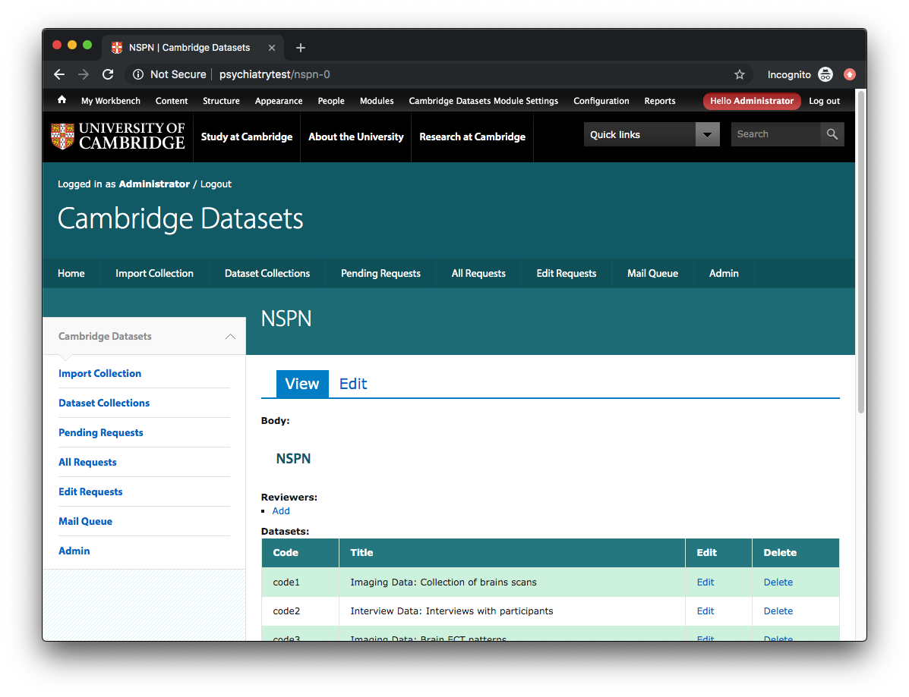

To add reviewers/final-reviewers, click on the “Add” link below “Reviewers”:

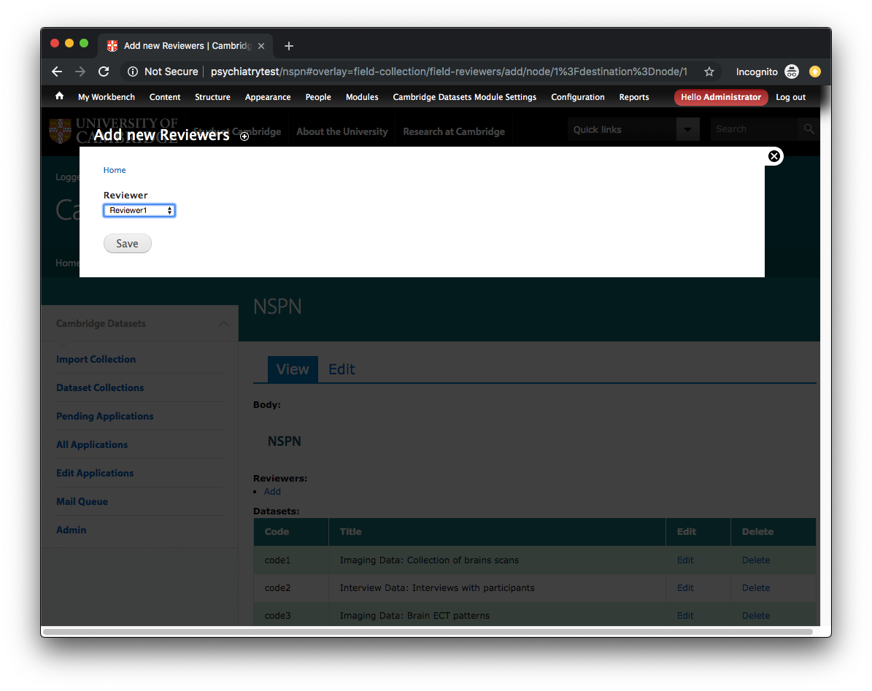

Add as many reviewers/final-reviewers as you need to, but be careful not to duplicate entries:

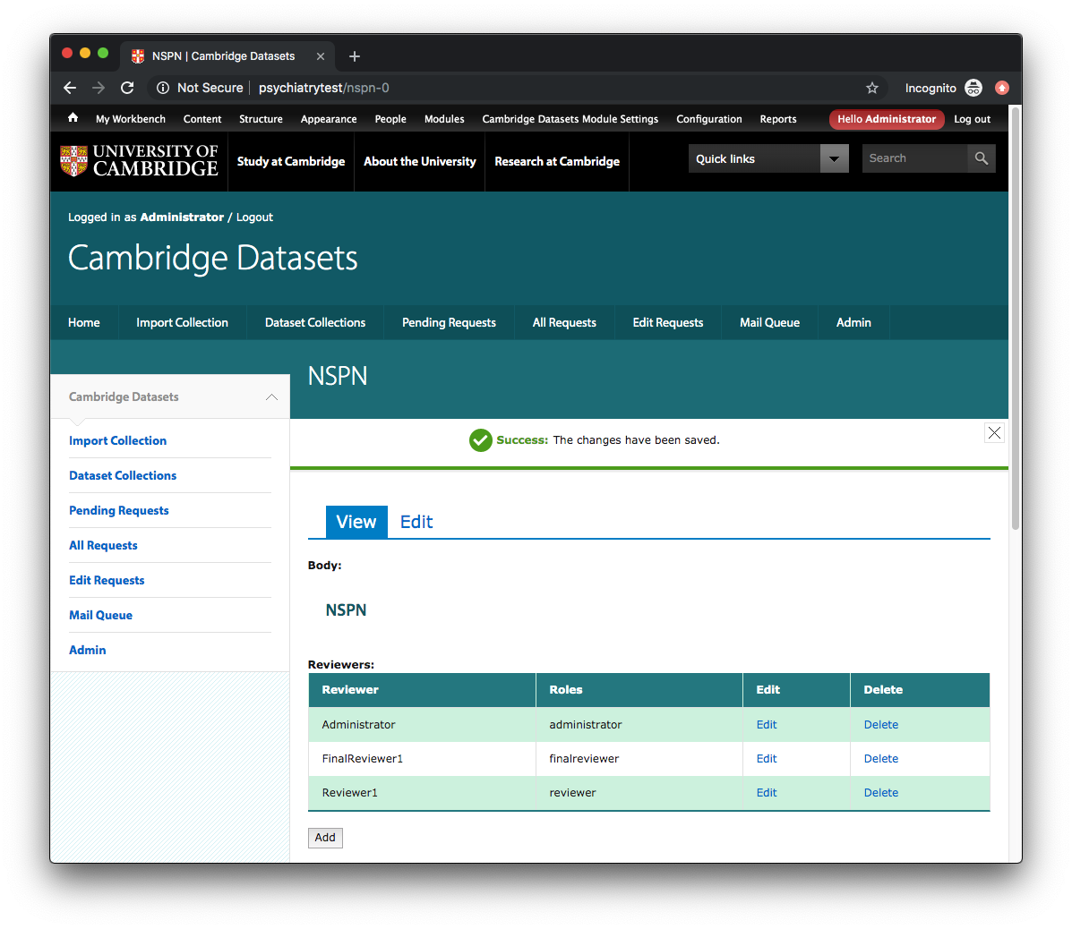

It is recommended that you add in the main “Administrator” user so they can see requests in the “Pending requests” screen.

#### Description of Additional Tabs available to Administrator

In addition to the “Import Collection”, “Dataset Collections” and “Admin” tabs covered above, the following tabs/functions are available to an administrator:

* **Pending Requests**  
  Show a list of all requests the current user has been delegated that have the status “Submitted”.
* **All Requests**  
  Show a list of all requests the current user has been delegated, regardless of status. This may be useful if a request has mistakenly been Rejected/Approved and has disappeared from the “Pending Requests” list.
* **Edit Requests**  
  Show a list of all requests across the entire system. This may be useful if a request has not been specifically delegated to the administrator but needs to be edited.
* **Mail Queue**  
  Shows a list of mail messages with their status. You can manually force sending of unsent messages by clicking on the “Process message queue” button:

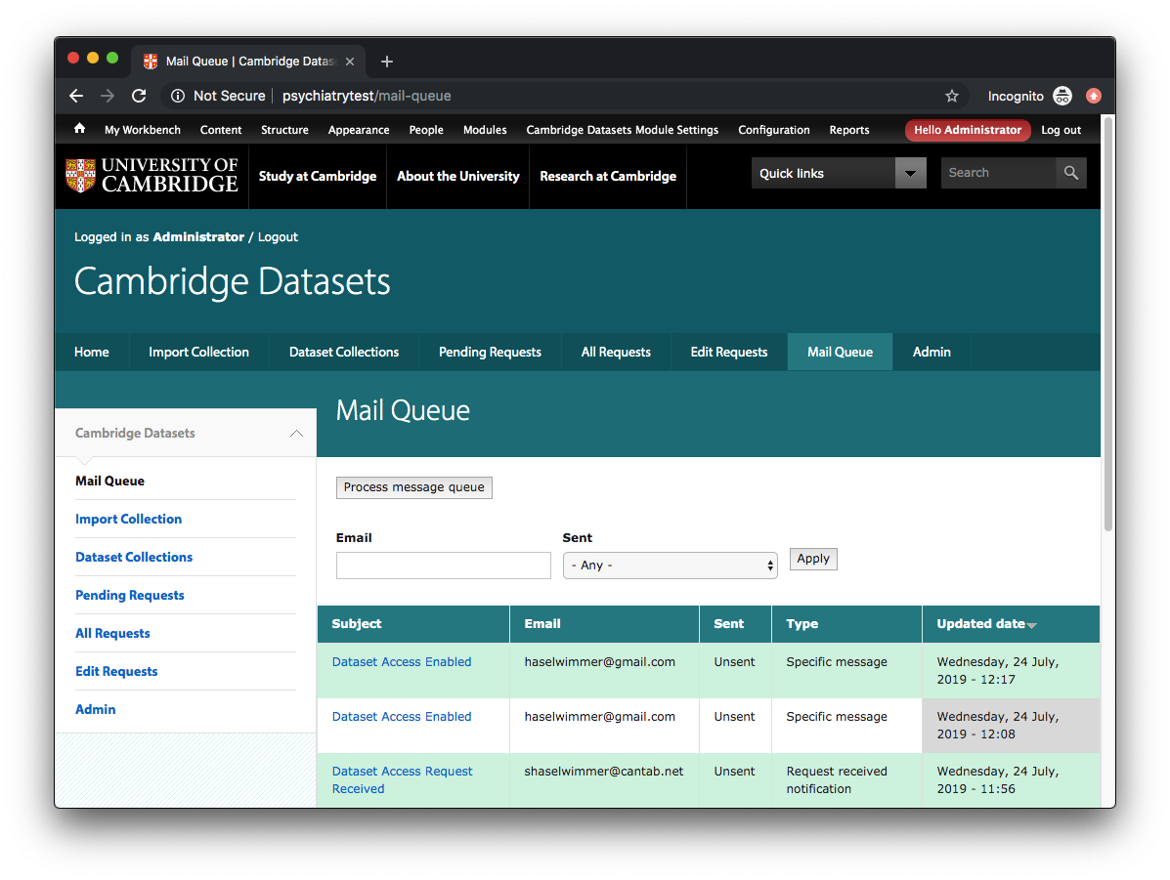

### 3.4. CSV Import File

The CSV file should consist of multiple lines of three comma-separated fields:

* **Code**The code of the specific dataset within the dataset collection
* **Title**  
  The title of the specific dataset within the dataset collection
* **Location**  
  The location of the specific dataset (*not currently used – may be used for automated access in future*)

As the file is a comma-separated file, none of the text fields above should contain commas (,). The CSV should also not include a “table header”, ie. the first line should be a line of data not a list of fields.

The contents of the sample CSV file at cambridge_datasets_application/sample/sample.csv is as follows:

**code1,Imaging Data: Collection of brains scans,/imaging/brain1  
code2,Interview Data: Interviews with participants,/interview/participants1  
code3,Imaging Data: Brain ECT patterns,/imaging/ect1  
code4,Interview Data: Post TV debrief,/interview/tvdebrief1  
code5,Clinical Trials: Bloods tests,/clinical/blood1**

## 4. Technical Overview

### 4.1. Drupal Content Types

|  |  |
| --- | --- |
| **Content Type** | Collection |
| **Description** | Stores a collection of datasets |
| **Extra Fields** (redundant fields not shown) | Title Body (used in “Dataset Overview” view) Terms & Conditions Text before main request form Text before list of datasets Reviewers [*field collection*\*] Datasets [*field collection*\*]  * **field_collection** and **field_collection_views** Drupal modules are used to manage many-to-many relationships including their display within admin screens and views. |

|  |  |
| --- | --- |
| **Content Type** | Dataset |
| **Description** | Stores information about the specific datasets within each dataset collection |
| **Extra Fields** (redundant fields not shown) | Title (= [Collection title]: [Dataset Title]) Code Dataset Title (Original dataset title from CSV file) Location  The “Title” field is designed to distinguish datasets with similar “Dataset titles” across different collections. When a dataset is imported, the “Title” field is constructed from the title of the dataset collection (input in the “Import Dataset” form) and the title of the specific dataset as defined in the CSV import file. This helps when selecting datasets during dataset collection editing, eg. when you need to distinguish between “*NSPN2018*: Post-survey interviews” and “*NSPN2019*: Post-survey interviews”. |

|  |  |
| --- | --- |
| **Content Type** | Mail |
| **Description** | Stores queued mail |
| **Extra Fields** (redundant fields not shown) | Type (“0” = Specific email, “1” = Request received notification) Sent Email Title Body  “Type” field is designed to avoid deluging reviewers with notification emails. If mail type = “0”, a new entry is added to mail queue for every new email request of that type (standard behaviour). If new email request of type “1” is received (notification behaviour), all existing Type 1 messages for that user are deleted before a new queue item is added. This prevents multiple duplicate “Request received” notifications being sent during cron runs. |

|  |  |
| --- | --- |
| **Content Type** | Request |
| **Description** | Stores every request the external user submits |
| **Extra Fields** (redundant fields not shown) | Title Collection Status First Name Last Name Email Position Institution Department Address Region Postcode Country Proposal Datasets [*field collection*\*] Reviewers [*field collection*\*] Reviews [*field collection*\*]  * **field_collection** and **field_collection_views** Drupal modules are used to manage many-to-many relationships including their display within admin screens and views. |

### 4.2. Drupal Views

|  |  |
| --- | --- |
| **View** | Administration |
| **Description** | Administration interface to allow setting of SMTP parameters, testing of email, and editing of users |
| **Access** | Administrator |

|  |  |
| --- | --- |
| **View** | All Requests |
| **Description** | List of requests that have been delegated to logged-in user |
| **Access** | Administrator Final Reviewer |

|  |  |
| --- | --- |
| **View** | Collection Overview |
| **Description** | Overview of specific dataset collection |
| **Access** | Any user |

|  |  |
| --- | --- |
| **View** | Collections |
| **Description** | List of all dataset collections |
| **Access** | Any user |

|  |  |
| --- | --- |
| **View** | Edit Requests |
| **Description** | Full list of all requests, regardless of whether logged-in user has been given delegated access |
| **Access** | Administrator |

|  |  |
| --- | --- |
| **View** | Field collection view – Datasets |
| **Description** | Sublist of datasets with edit/delete functionality |
| **Access** | *Dependent on inclusion in parent view* |

|  |  |
| --- | --- |
| **View** | Field collection view - Datasets (Read only) |
| **Description** | Sublist of datasets with no edit/delete functionality |
| **Access** | *Dependent on inclusion in parent view* |

|  |  |
| --- | --- |
| **View** | Field collection view – Reviewers |
| **Description** | Sublist of reviewers with edit/delete functionality |
| **Access** | *Dependent on inclusion in parent view* |

|  |  |
| --- | --- |
| **View** | Field collection view – Reviews |
| **Description** | Sublist of reviews with edit/delete functionality |
| **Access** | *Dependent on inclusion in parent view* |

|  |  |
| --- | --- |
| **View** | Field collection view - Reviews (Read only) |
| **Description** | Sublist of reviews with no edit/delete functionality |
| **Access** | *Dependent on inclusion in parent view* |

|  |  |
| --- | --- |
| **View** | Mail Queue |
| **Description** | List of items in mail queue |
| **Access** | Administrator |

|  |  |
| --- | --- |
| **View** | Pending Requests |
| **Description** | List of submitted requests the user has access to |
| **Access** | Reviewer Final Reviewer Administrator |

|  |  |
| --- | --- |
| **View** | Review All Requests |
| **Description** | Review all requests the user has access to |
| **Access** | Final Reviewer Administrator |

|  |  |
| --- | --- |
| **View** | Review Pending Requests |
| **Description** | Review all submitted requests the user has access to |
| **Access** | Reviewer Final Reviewer Administrator |

### 4.3. PHP Code

The majority of the PHP code used in the application is located in the **cambridge_datasets** module, specifically:

drupal/profiles/cambridge_datasets_application/modules/features/cambridge_datasets/cambridge_datasets.module

There are also snippets of PHP code used in the following Drupal views:

* Collections
* Review All Requests
* Review Pending Requests

### 4.4 Drupal Tutorial

To understand more about Drupal 7, go to <https://www.drupal.org/docs/7>